Year | Mathematics Test  Polygons and Circles
 | Name

Answer all questions in the spaces provided on this test paper by
Writing the answer in the box provided.
or
Shading in the bubble for the correct answer from the four choices provided.
Show any working out on the test paper.
Diagrams are not to scale.
1. | 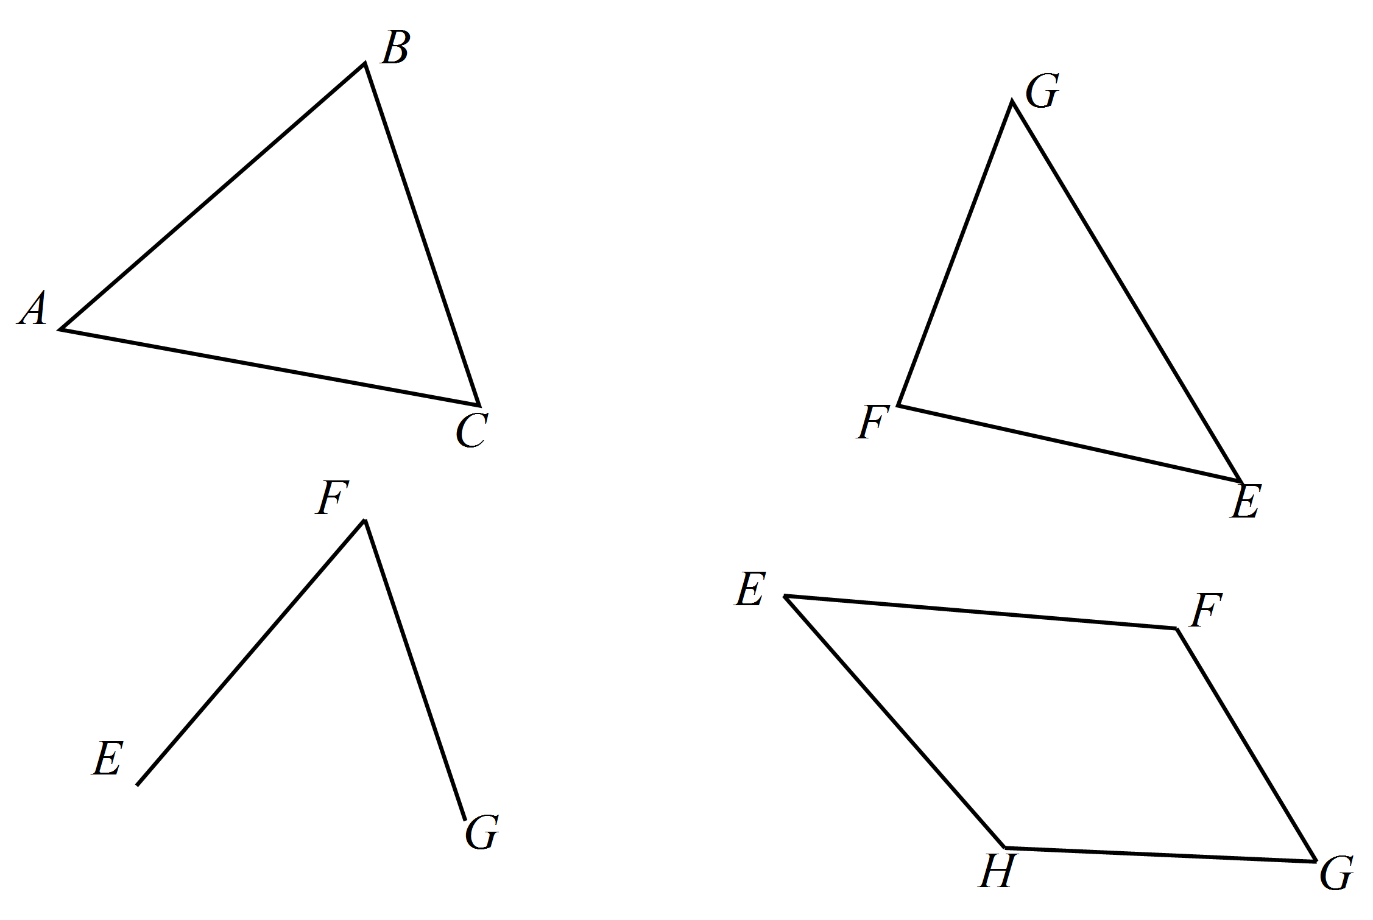Which figure would be called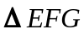?
2. | Which figure below has markings showing it has two pairs of equal sides and one pair of equal angles?  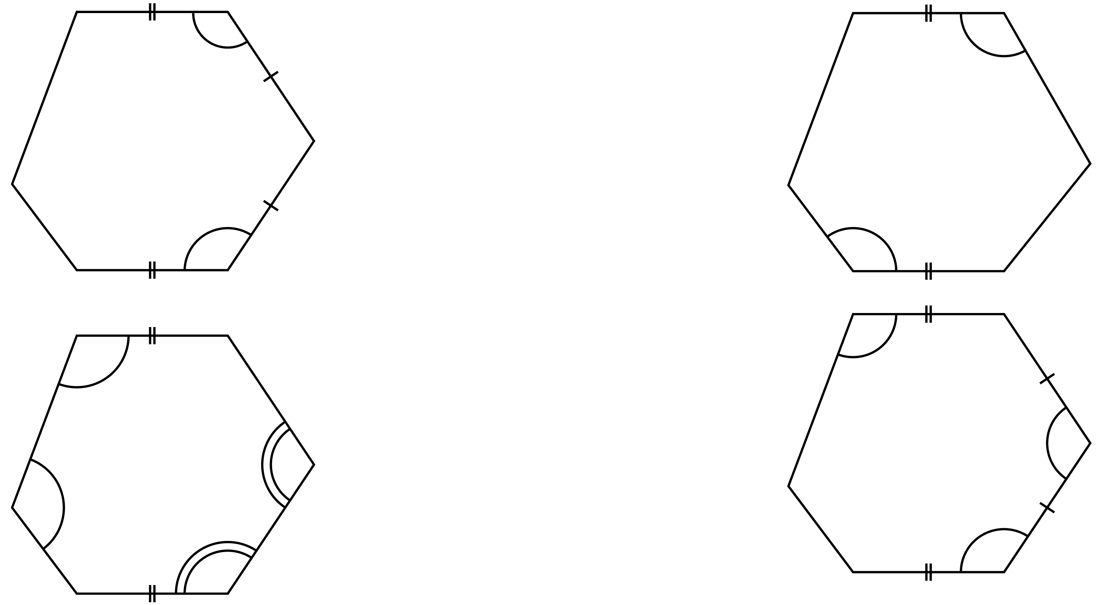
3. | 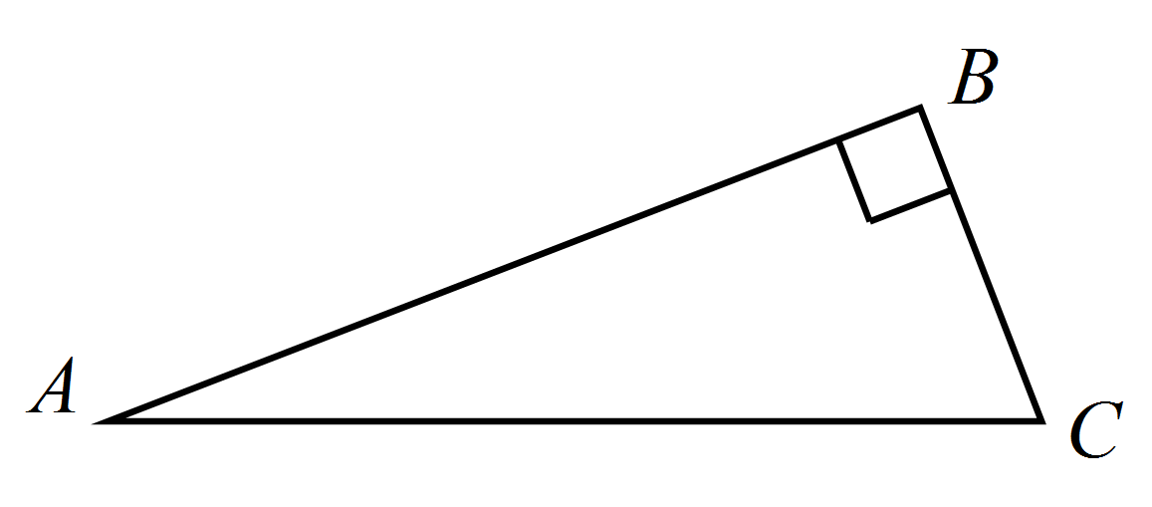Triangle ABC is a: Right isosceles triangle.  Acute scalene triangle.  Right isosceles triangle.  Right scalene triangle
4. | 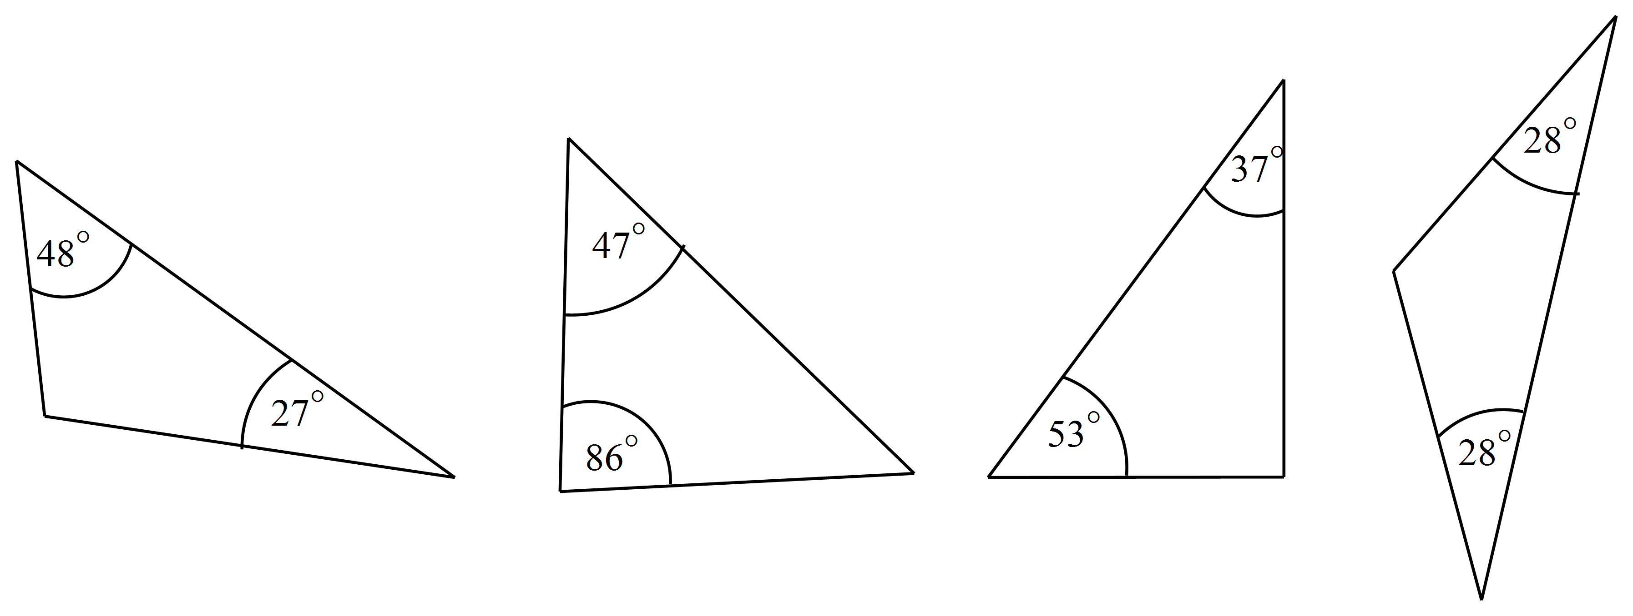Which triangle below is an obtuse isosceles triangle?
5. | 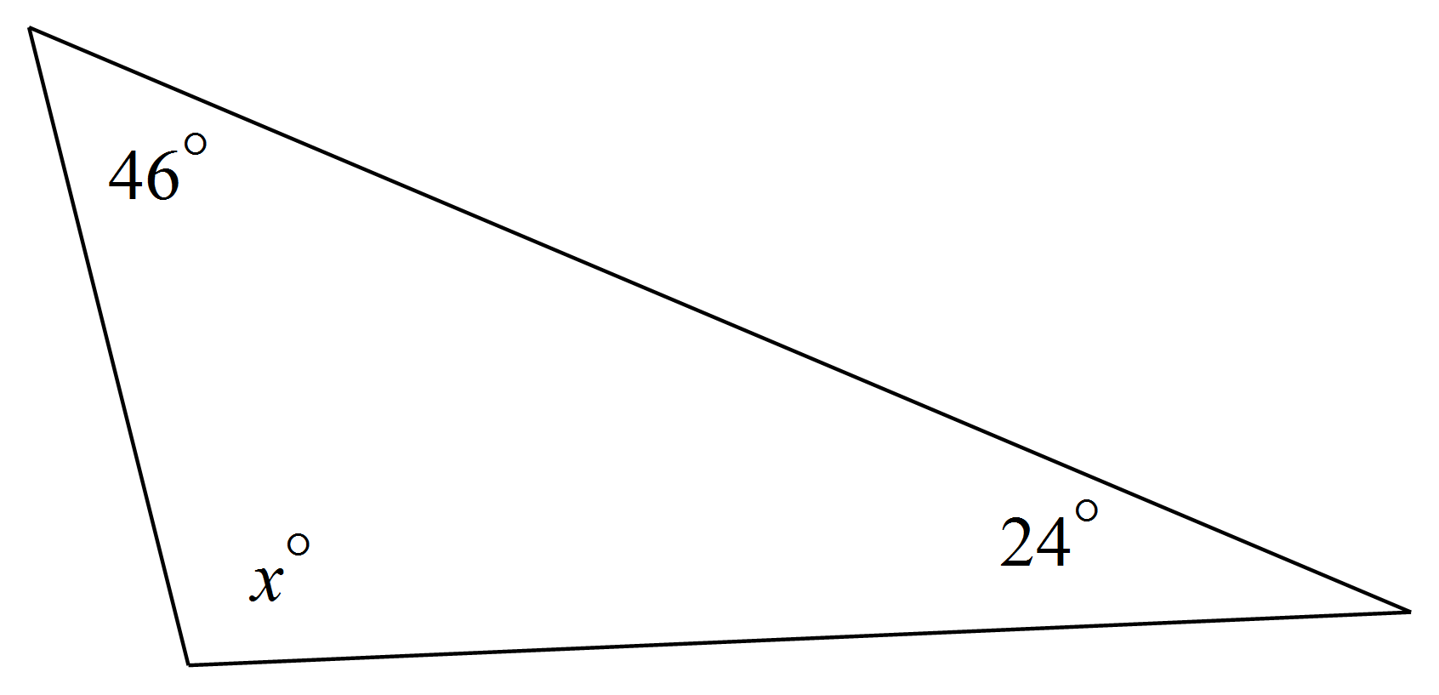The value of x is:  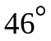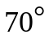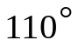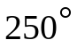
6. | Find the value of y in the diagram below.  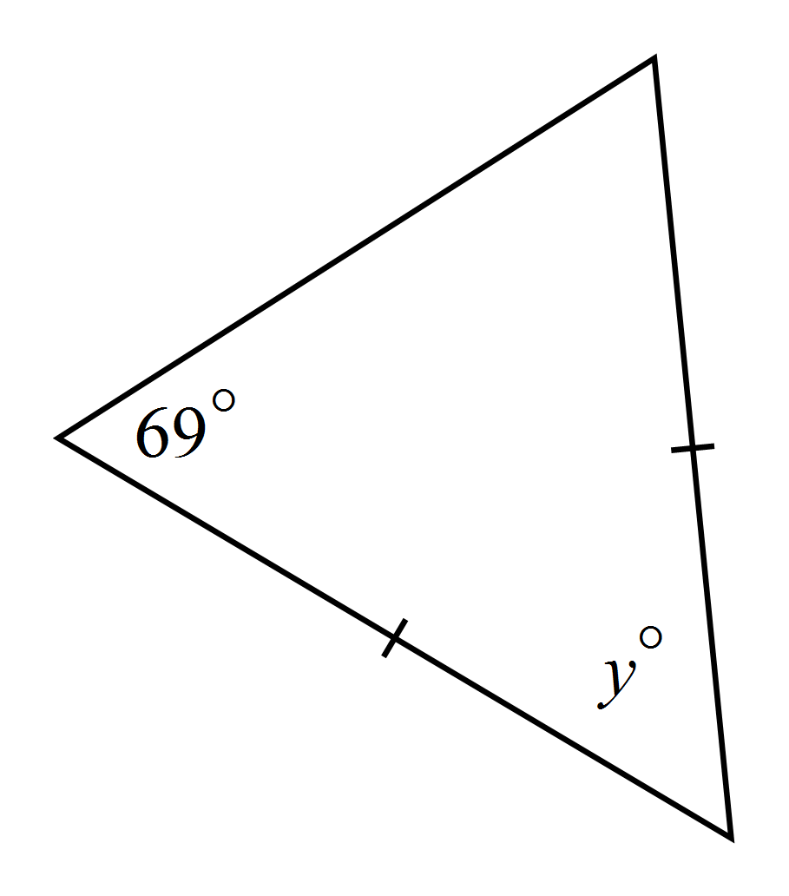  y =
7. | What is the size of the shaded angle?  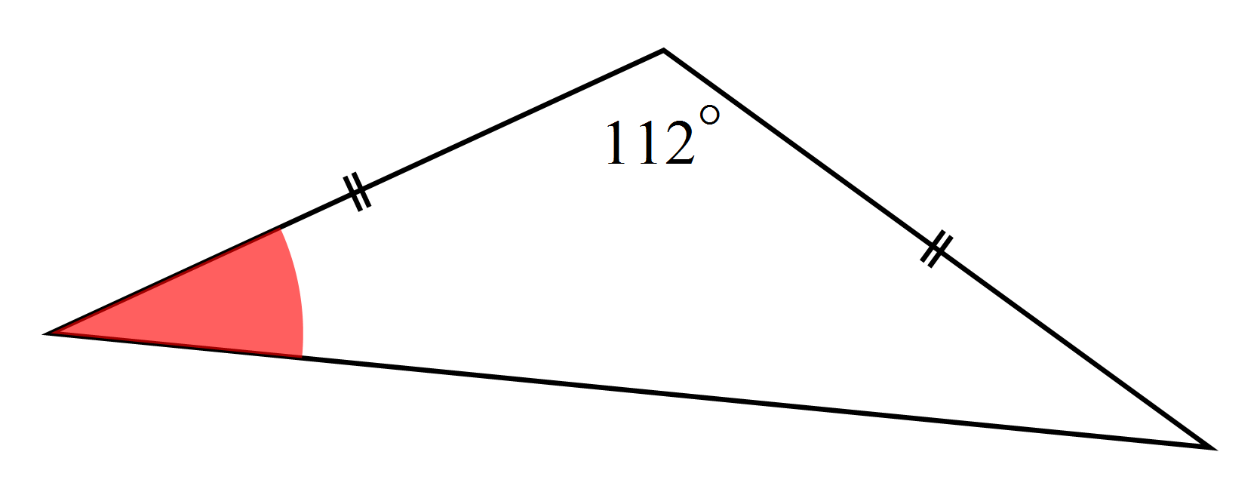  Not to scale.
8. | What is the size of the exterior angle CBD?  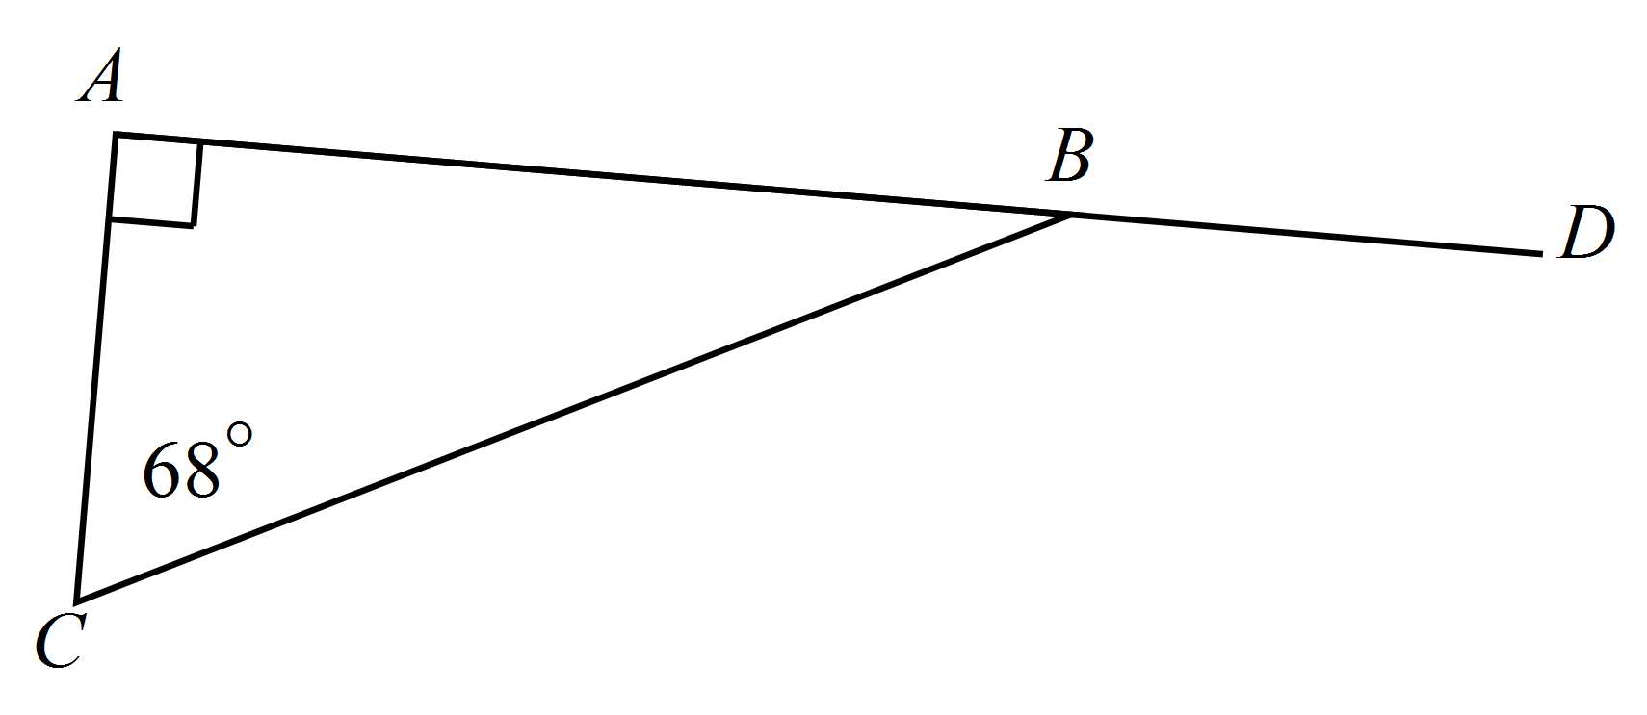  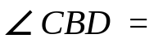
9. | Which of the following is not true of an obtuse isosceles triangle?  The angle sum is 180º.  All the angles are obtuse.  There are two equal sides.  There are two equal angles.
10. | 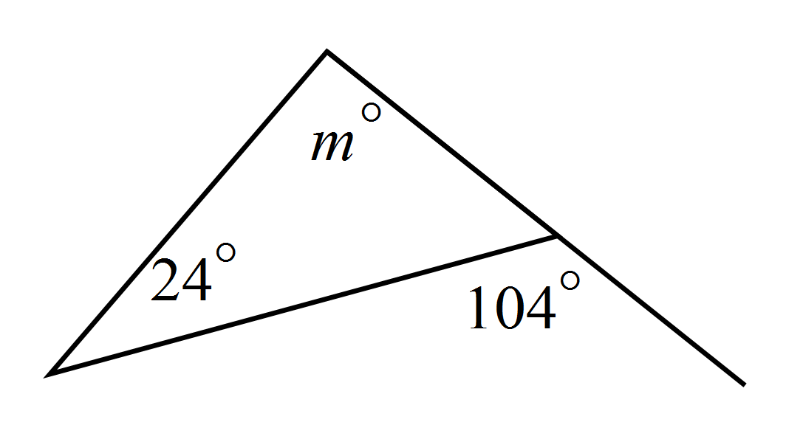Which is true?  m = 24º  m = 80º  m = 100º  m = 128º
11. | Which diagram below shows a non-convex quadrilateral?  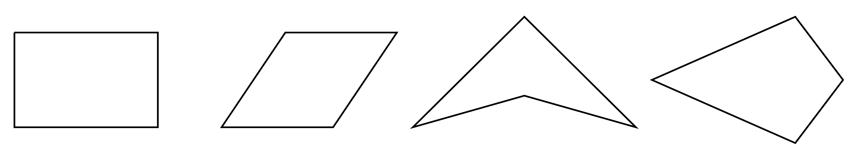
12. | 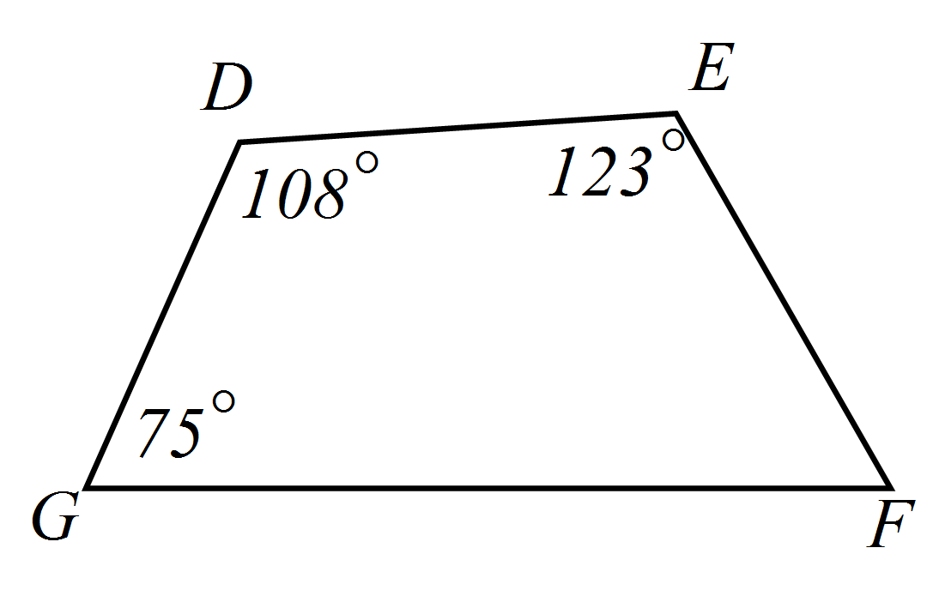What is the size of angle EFG?  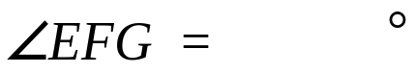
13. | Which of the following is not a property of a parallelogram?  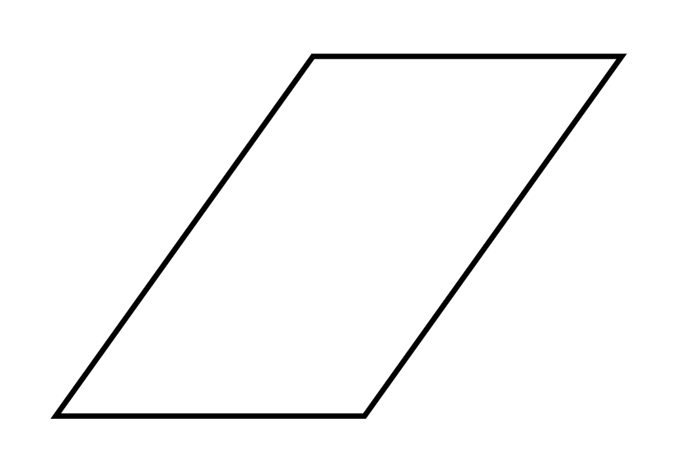  The angle sum is 360º.  The diagonals are equal in length.  The opposite sides are equal.  The opposite angles are equal.
14. | PQRS is a kite. The diagonals intersect at T. What is the value of x ?  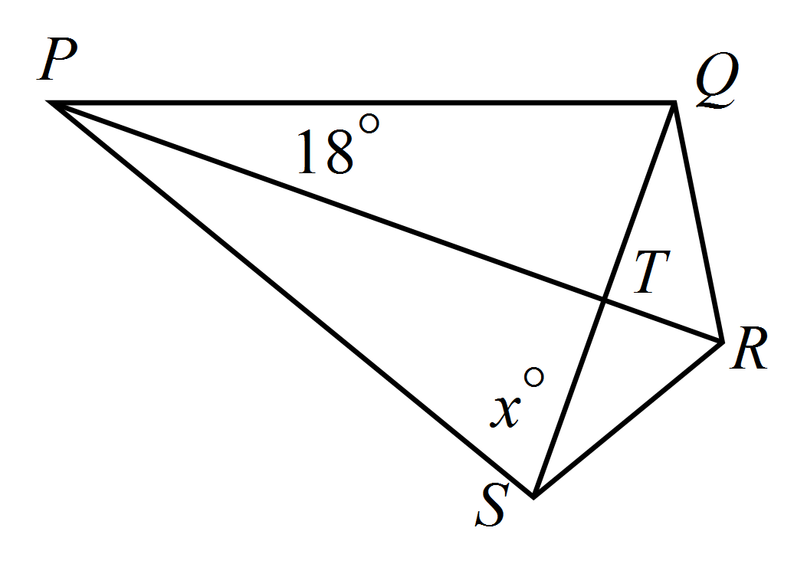  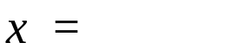
15. | 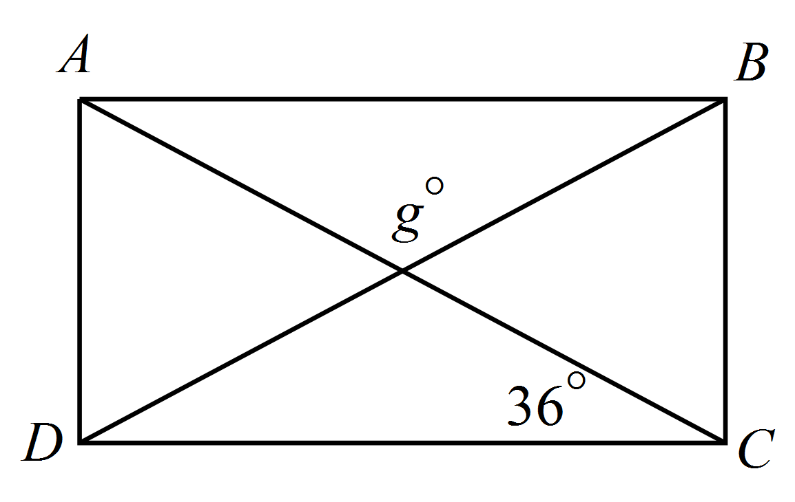ABCD is a rectangle. What is the value of g?  g = 36º  g = 72º  g= 108º  g = 144º
16. | 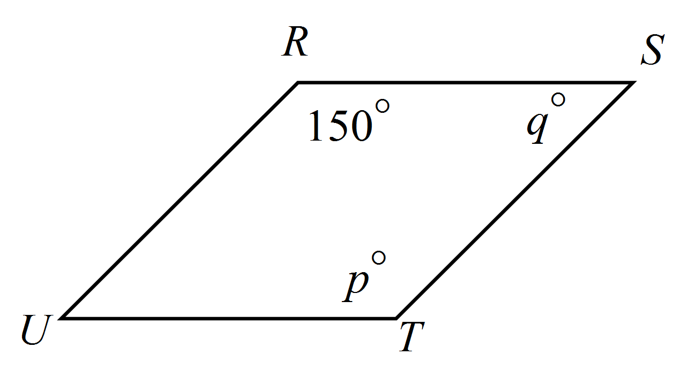RSTU is a rhombus.  Which is true?  p = 30º and q = 30º.  p = 30º and q = 150º.  p = 150º and q = 30º.  p = 150º and q = 150º.
17. | Which statement is true of a square?  The angle sum is 360º and the diagonals are unequal.  The diagonals are equal in length and intersect at an angle of 45º.  All sides are equal and all angles are 45º.  The diagonals bisect one another at right angles.
18. | In which of these quadrilaterals do the diagonals bisect the angles of the quadrilateral?  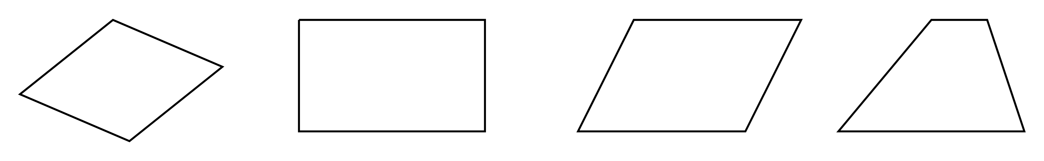  Rhombus Rectangle. Parallelogram Trapezium.
19. | 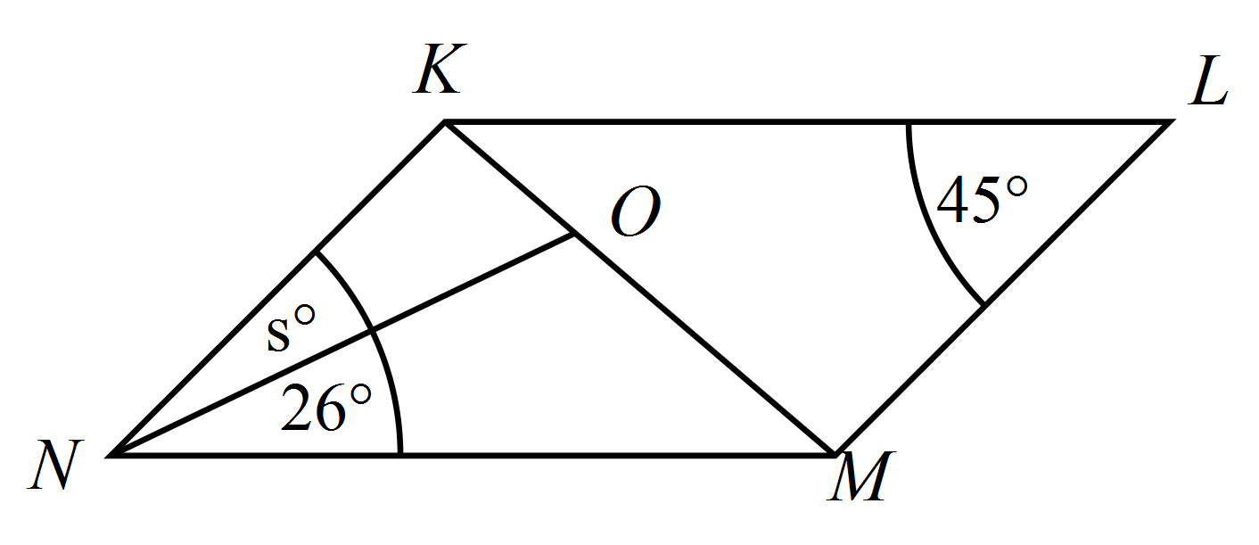KLMN is a parallelogram.  O is a point on the diagonal KM.  What is the value of s?  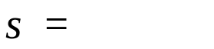
20. | Draw a neat sketch of a rhombus with 5 cm sides.
21. | How many axes of line symmetry does a kite have?
22. | Which best describes the rotational symmetry of the irregular hexagon shown.  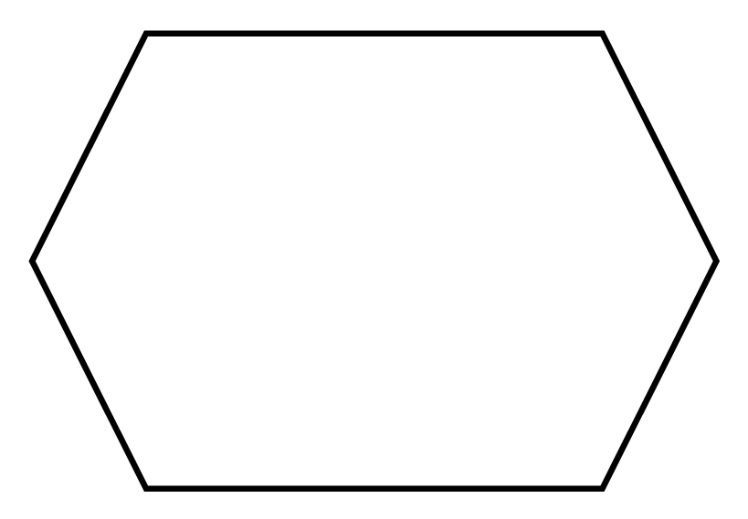There is no rotational symmetry.  There is rotational symmetry of order 2.  There is rotational symmetry of order 3.  There is rotational symmetry of order 6.
23. | If the triangle ABC is reflected in the side BC, which quadrilateral is formed?  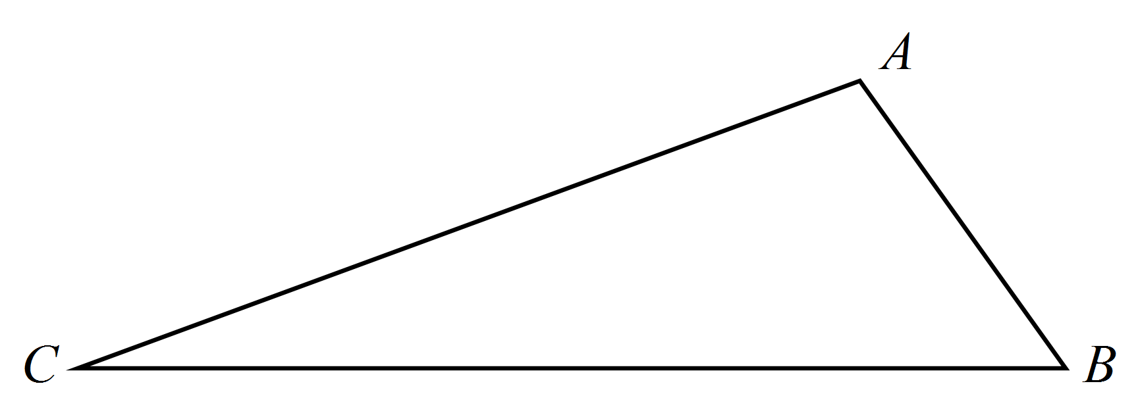  Rhombus Rectangle. Parallelogram Kite.
24. | Which is true about the circle with two diameters drawn?  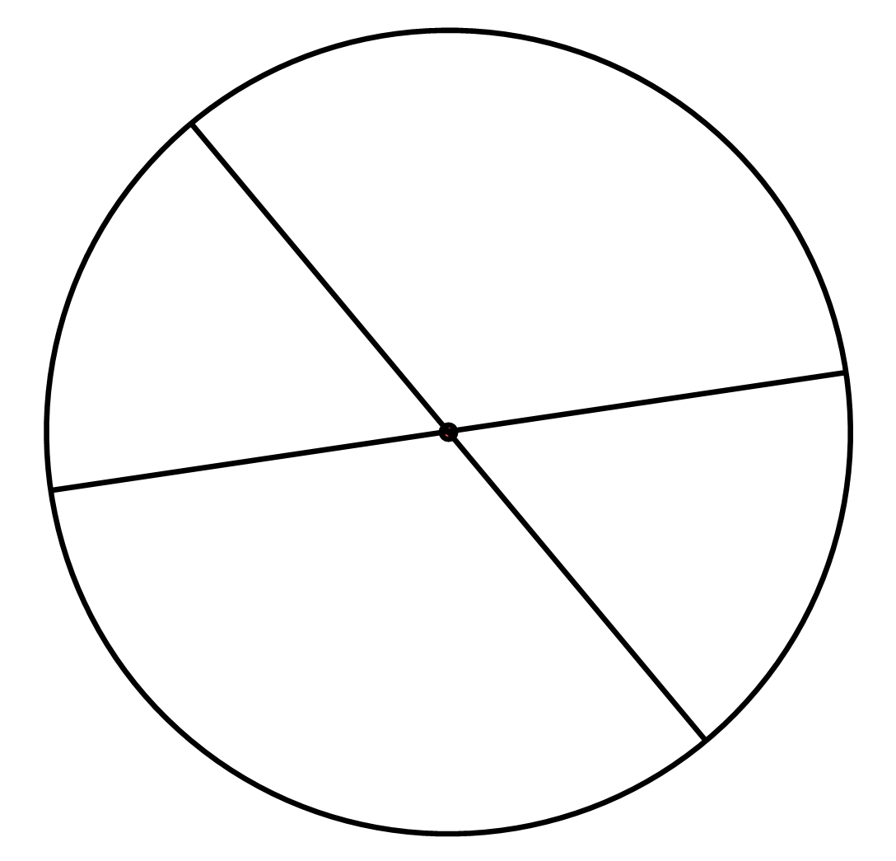  There is no rotational symmetry.  There is rotational symmetry of order 3.  There is no line symmetry.  There are two axes of line symmetry
25. | Q is the midpoint of FG.  Rotate the trapezium EFGH through 180º clockwise about the point Q.  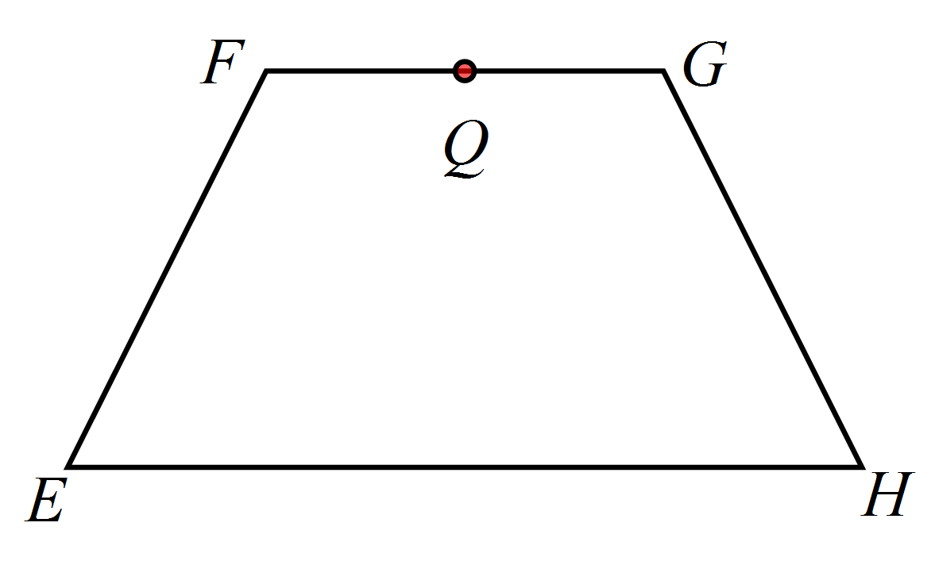

Year |  | Mathematics Test  Polygons and Circles
 |  | ANSWERS
Answer all questions in the spaces provided on this test paper by
Writing the answer in the box provided.
or
Shading in the bubble for the correct answer from the four choices provided.
Show any working out on the test paper.
Diagrams are not to scale.
1. | Which figure would be called?
2. | Which figure below has markings showing it has two pairs of equal sides and one pair of equal angles?
3. | Triangle ABC is a: Right isosceles triangle.  Acute scalene triangle.  Right isosceles triangle.  Right scalene triangle
4. | Which triangle below is an obtuse isosceles triangle?
5. | The value of xº is:
6. | Find the value of y in the diagram below.  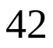  y =
7. | What is the size of the shaded angle?  Not to scale.  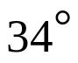
8. | What is the size of the exterior angle CBD?  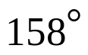
9. | Which of the following is not true of an obtuse isosceles triangle?  The angle sum is 180º.  All the angles are obtuse.  There are two equal sides.  There are two equal angles.
10. | Which is true?  m = 24º  m = 80º  m = 100º  m = 128º
11. | Which diagram below shows a non-convex quadrilateral?
12. | What is the size of angle EFG?  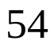
13. | Which of the following is not a property of a parallelogram?  The angle sum is 360º.  The diagonals are equal in length.  The opposite sides are equal.  The opposite angles are equal.
14. | PQRS is a kite. The diagonals intersect at T. What is the value of x ?  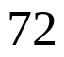
15. | ABCD is a rectangle. What is the value of g?  g = 36º  g = 72º  g= 108º  g = 144º
16. | RSTU is a rhombus.  Which is true?  p = 30º and q = 30º.  p = 30º and q = 150º.  p = 150º and q = 30º.  p = 150º and q = 150º.
17. | Which statement is true of a square?  The angle sum is 360º and the diagonals are unequal.  The diagonals are equal in length and intersect at an angle of 45º.  All sides are equal and all angles are 45º.  The diagonals bisect one another at right angles.
18. | In which of these quadrilaterals do the diagonals bisect the angles of the quadrilateral?  Rhombus Rectangle. Parallelogram Trapezium.
19. | KLMN is a parallelogram.  O is a point on the diagonal KM.  What is the value of s?  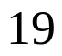
20. | Draw a neat sketch of a rhombus with 5 cm sides.  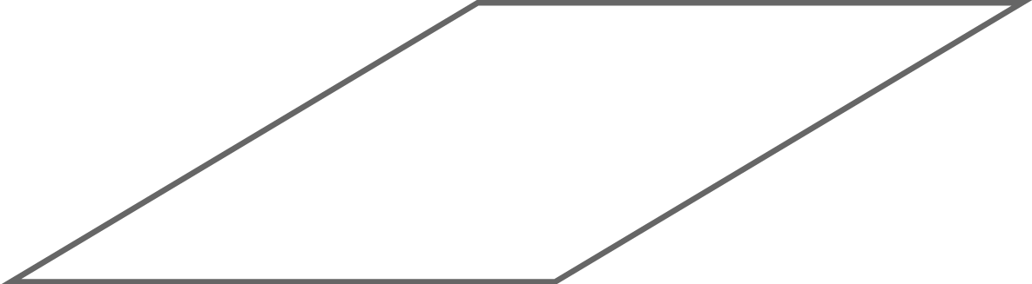
21. | How many axes of line symmetry does a kite have?  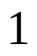
22. | Which best describes the rotational symmetry of the irregular hexagon shown.  There is no rotational symmetry.  There is rotational symmetry of order 2.  There is rotational symmetry of order 3.  There is rotational symmetry of order 6.
23. | If the triangle ABC is reflected in the side BC, which quadrilateral is formed?  Rhombus Rectangle. Parallelogram Kite.
24. | Which is true about the circle with two diameters drawn?  There is no rotational symmetry.  There is rotational symmetry of order 3.  There is no line symmetry.  There are two axes of line symmetry
25. | Q is the midpoint of FG.  Rotate the trapezium EFGH through 180º clockwise about the point Q.  